

YEAR: 11

SUBJECT: 2A Human Biological Science

TEST: Task 4 Circulation, Respiration and Lymphatic systems
TIME: 60 minutes
QUESTIONS: 20 Multiple Choice, 7 Short Answer, 1 Extended Answer
TOTAL MARKS: 70

DO NOT WRITE ON OR MARK THIS PAPER

SECTION ONE—MULTIPLE CHOICE (20 marks)

This section has 20 questions. Answer all questions on the separate Multiple-choice Answer Sheet provided.

Question 1
The windpipe is the common name for:
- larynx
- pharynx
- trachea
- diaphragm

Question 2
During the process of expiration the:
- diaphragm lowers
- ribs move upwards and outwards
- size of the thoracic cavity increases
- pressure inside the thoracic cavity increases

Question 3
Ventilation is the process by which air is moved into and out of the lungs. Which of the following statements about the process is correct? Air
- flows from places of higher pressure to places of lower pressure
- pressures are always equal
- flows from places of lower pressure to places of higher pressure
- is released from the lungs into the heart

Question 4
The lungs are well suited to gas exchange because:
- they are small in size, there is little surface area for gaseous diffusion and each alveolus has restricted blood flow
- they are found deep inside the body to reduce evaporation, have a large surface area for gaseous diffusion and each alveolus has is well supplied with blood
- they are moist, have a small surface area for gaseous diffusion and blood flow changes depending on the amount of oxygen present
- none of the above

Question 5
The correct sequence of structures through which oxygen would pass through the respiratory system is:
- nasal cavity, trachea, larynx, pharynx, bronchi, bronchioles, alveoli
- larynx, trachea, pharynx, bronchioles, alveoli, bronchi
- bronchioles, bronchi, alveoli, nasal cavity, pharynx, larynx, trachea
- nasal cavity, pharynx, larynx, trachea, bronchi, bronchioles, alveoli

Question 6
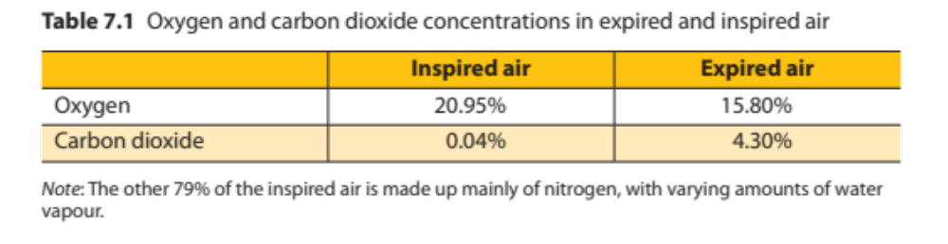
From this table it can be stated that from the total amount of oxygen inspired: on average
- 25% remains in the body for use by cells
- 15% remains in the body for use by cells
- 30% remains in the body for use by cells
- 20% remains in the body for use by cells

Question 7
Which of the following does not help to maintain the diffusion gradients between the alveoli and capillaries?
- combination of oxygen with haemoglobin in the red blood cells
- the beating of the heart to maintain blood flow
- continual movement of tidal air through the bronchioles
- accumulation of carbon dioxide within the alveolar sac

Question 8
The diagram below represents a section of an alveolus and a capillary that surrounds it.

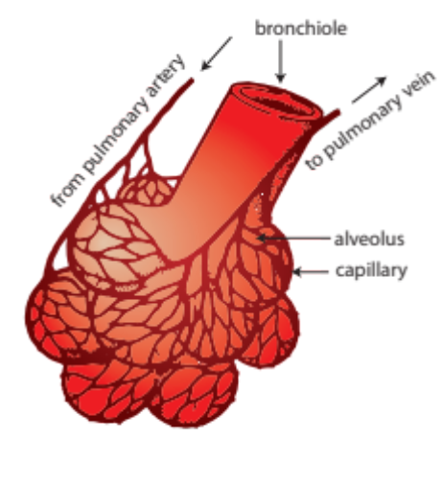
X
Y
As the blood moves from X to Y it:
- gains oxygen and becomes darker red
- loses oxygen and becomes brighter red
- gains oxygen and becomes brighter red
- loses oxygen and becomes darker red

Question 9
Carbon dioxide is carried in the blood mainly by the:
- lymph
- red blood cells
- white blood cells
- plasma

Question 10
One function of platelets is to:
- assist in the clotting of blood
- carry haemoglobin
- ingest bacteria
- transport carbon dioxide

Question 11
Erythrocytes primarily carry:
- carbon dioxide
- oxygen and carbon dioxide
- oxygen
- oxygen and nitrogen

Question 12
White blood cells (leucocytes) can be distinguished from red blood cells because they:
- have a bi-concave shape
- have a nucleus
- contain haemoglobin
- move in groups

Question 13
The presence of valves between the chambers of the heart ensures:
- blood is maintained at a constant pressure
- blood can move directly into the aorta
- blood flow is restricted to one direction
- all chambers of the heart can fill with blood simultaneously

Question 14
During the cardiac cycle the following events take place;
- atrial systole
- diastole
- ventricular systole

In which order do the events occur?
- atrial systole, diastole, ventricular systole
- diastole, ventricular systole, diastole
- ventricular systole, atrial systole, diastole
- atrial systole, ventricular systole, diastole

Question 15
In which of the following blood vessels would you expect blood pressure to be the highest?
- Vena cava
- Pulmonary artery
- Aorta
- Pulmonary vein

Question 16
Lymph most closely resembles which of the following?
a) Plasma
b) Urine
c) Tissue fluid
d) Blood

Question 17
The lymphatic system carries out each of the following functions except the:
- transport of glucose substances from the blood to the cells
- return of the fluid to the blood stream
- removal of impurities from the lymph
- involvement in immune response

Question 18
Pus is formed when special cells of the immune system enter a site of infection and ingest or engulf foreign matter. These cells are called:
- T cells
- phagocytes
- lymphocytes
- antigens

Question 19
The lymphatic system consists of:
- a network of lymph capillaries joined to lymph vessels and associated lymph nodes
- circulatory capillaries and associated glands joined in a network
- circulatory capillaries joined to the arterial and venous network
- lymph vessels connected to circulatory capillaries and lymph nodes

Question 20

The rings in the wall of the trachea

- prevent it collapsing under pressure
- make it larger
- prevent it filling with mucus
- enable air to be forced out of the lungs

Task 4 Respiration, Circulation and Lymph Test:
2A Human Biological Science
2018
ANSWER BOOKLET

NAME:
FORM: DATE:

Multiple Choice Short Answer Extended Answer Total

/20

/40

/10

/70

SECTION ONE: Multiple choice answers
Cross (X) through the correct answer.

1 | a | b | c | d |  | 11 | a | b | c | d
2 | a | b | c | d |  | 12 | a | b | c | d
3 | a | b | c | d |  | 13 | a | b | c | d
4 | a | b | c | d |  | 14 | a | b | c | d
5 | a | b | c | d |  | 15 | a | b | c | d
6 | a | b | c | d |  | 16 | a | b | c | d
7 | a | b | c | d |  | 17 | a | b | c | d
8 | a | b | c | d |  | 18 | a | b | c | d
9 | a | b | c | d |  | 19 | a | b | c | d
10 | a | b | c | d |  | 20 | a | b | c | d

SECTION TWO – SHORT ANSWER
Seven questions worth 40 marks
Complete all answers in wither blue or black pen.

Question 21
The following diagram shows a number of body cells and their neighbouring capillary supply

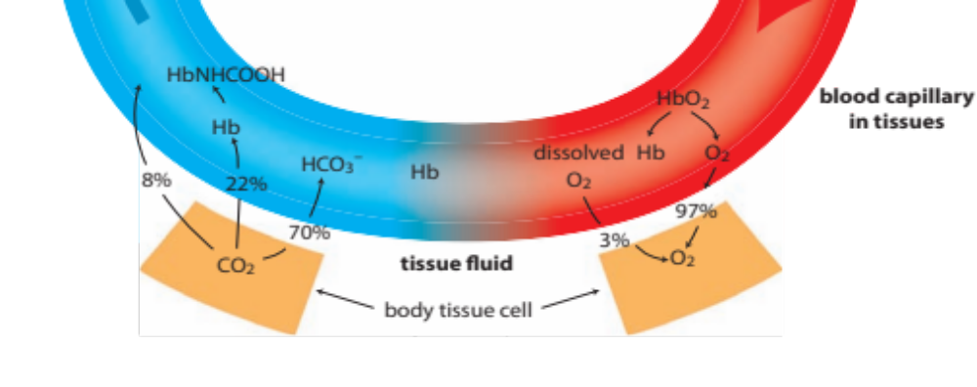
X
Structure A
Structure B

- Name structure A and B (1 mark)

- Name the fluid that occupies space X (1 mark)

- Which components that are found in blood will not be present in the fluid of space X?
(2 marks)

- Name four substances that pass from structure A, through space X and into the structure B.
(2 marks)

Question 22
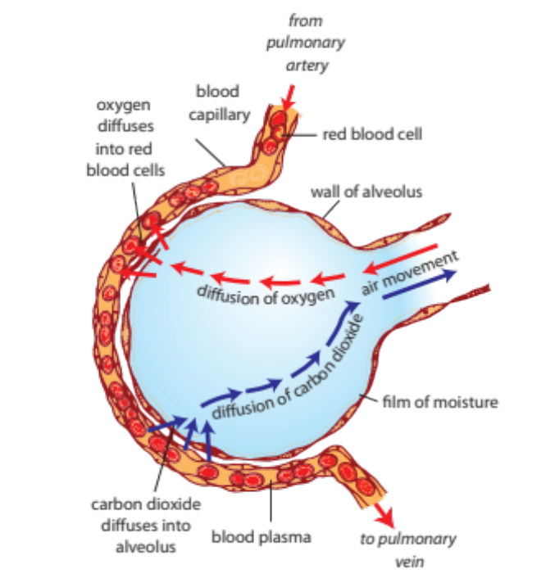
B
A
C
D

- Complete the table below (4 marks)

Label | Structure
A
B
C
D

- Describe two reasons why oxygen moves from the air in the alveoli into the blood stream (2 marks)

Question 23

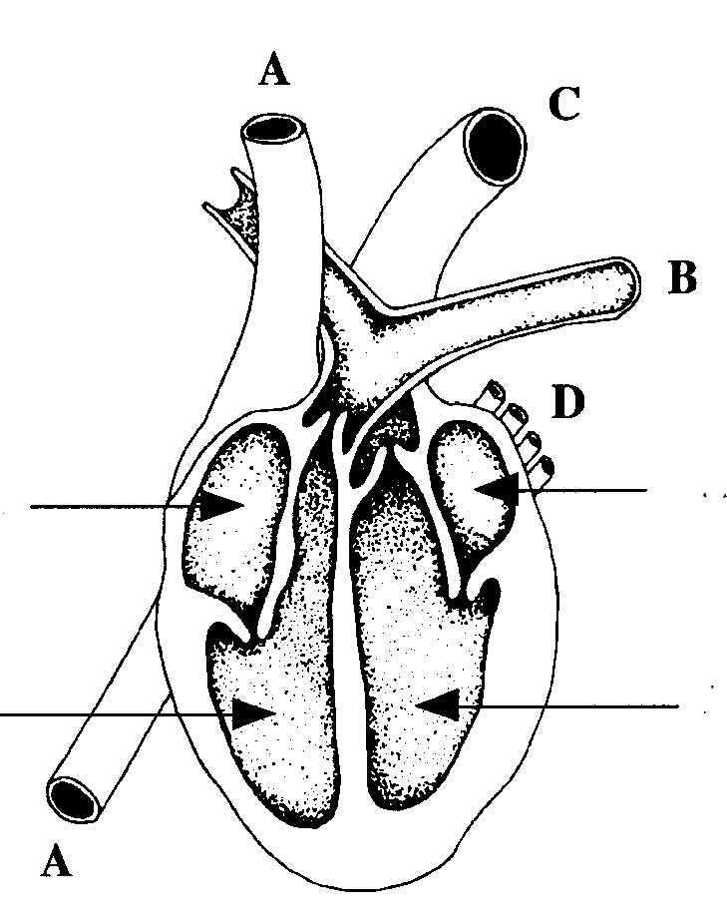
E
F

G
H
E
F

G
H

- Name the valves that prevent blood from flowing between B and F. (1 mark)

- Which chamber of the heart does the greatest work? Give evidence to support your answer. (2 marks)

- Using the letters indicated on the diagram state which vessels and which chambers contain oxygenated blood (2 marks)

- Label structure D and G (2 marks)

Question 24

. Complete the Table below for each type of blood vessel stated, giving (a) one function it serves, and (b) one structural feature which helps it carry out the function. (6 marks)

Blood Vessel | Function | Structural Feature
1. Artery | (a) | (b)
2. Capillary | (a) | (b)
3. Vein | (a) | (b)
)

Question 25
a) Explain the difference between breathing and respiration. (2 marks)

b) Describe what happens when you breathe in. (2 marks)

Question 26

- Explain two ways in which blood flow to an organ can be increased. (2 marks)

- What changes occur in blood flow during exercise? (3 marks)

Question 27 (5 marks)

The process of respiration involves several processes and structures. Give the correct biological term described by the following.

- A flap of tissue which, when swallowing, closes off the trachea so that food and liquid cannot enter the lungs.

_____________________

- The membrane which covers the lungs and lines the inside of the chest.

_____________________

- Breathing in _____________________

- Muscles between the ribs which move the rib cage upwards and outwards to increase the volume of the lungs.

_____________________

- Gas which diffuses from the blood into the lungs.

_____________________

Question 28

What are the advantages of having a lymphatic system? (4 marks)

_______________________________________________________________________________

_______________________________________________________________________________

________________________________________________________________________________

________________________________________________________________________________

________________________________________________________________________________

________________________________________________________________________________

________________________________________________________________________________

________________________________________________________________________________

SECTION THREE – EXTENDED ANSWER
One question worth 10 marks
Answer question using blue or black pen and pencil for the diagrams.

Question 29
- Explain how deoxygenated blood flows through your heart to become oxygenated and then how oxygenated blood leaves the heart to become oxygenated. Within your answer, explain the components that keep the blood flowing in its correct path. (6 marks)

- Explain why someone with an infected toe may experience a lump in his or her groin.
(4 marks)

________________________________________________________________________
_______________________________________________________________________________________________________________________________________________________________________________________________________________________________________________________________________________________________________________________________________________________________________________________________________________________________________________________________________________________________________________________________________________________________________________________________________________________________________________________________________________________________________________________________________________________________________________________________________________________________________________________________________________________________________________________________________________________________________________________________________________________________________________________________________________
_______

END OF TEST

